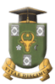
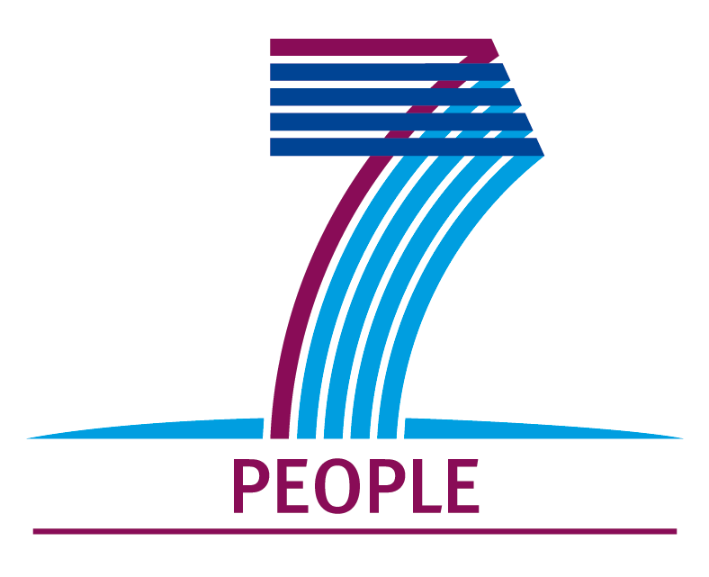
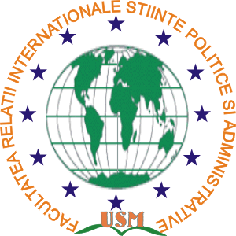

Moldova State Universitaty
International Scientific Conference
”Political Science and the Changing Society”

Chişinău, November 13th , 2015

AGENDA
hour/  timetable | Sessions |  | Bl. nr.6  hall
Thursday, November 12, 2015

Arrivals of foreign participants
Accommodation

Friday, November 13, 2015

09:00-09:30  09:30-10:00  10:00-11:30 |  | Registration of participants  Official Opening of the International Scientific Conference dedicated to 20 years Anniversary of the International Relations, Political and Administrative Sciences Faculty: Political Science and the Changing Society  Plenary session. | 114  114
11:30- 12:00 |  | Coffee- break
12:00-17:00 |  | Work in sections | 207, 208, 212, 306, 316
13:00-14:00 |  | Lunch/ Coffee-Break
17:00-17:30 |  | Debates and conclusions. Conference summary | 114
18:00-20:00 |  | Official dinner
Saturday 14, 2015

10:00-12:00 |  | Excursion Chisinau.  Participants Departure

